Sprint 0 en 1

Planning meeting:
- Made userstories for sprint 1.
- Discussing who will make what userstory.
- Discussing how the system is builded.

Refined the user stories (19-03): We’ve changed the userstories so it would be more uniform overall, going more into depth to clear up what we wanted to reach with each item while still making it understandable for those with little to no knowledge about coding.
Changed the ERD (19-03 - 31-03): We’ve added and removed a couple of things in our ERD, the main problem we had was two many to many relations, and this isn’t allowed. Adding and removing tables allowed us to get rid of these many to many relations which weren’t allowed.

This often caused issues with providing a system that worked with all the criteria it needed to meet, while also not infringing upon other systems which we would not develop.

Sprint 2
Worked on the retrospective(09-04): We’ve made action points to achieve what we want to stop, and start doing in sprint 2.

Planning meeting (09-04):
- Made userstories for sprint 2.
- Discussing who will make what userstory.

Screenshot of planning meeting:
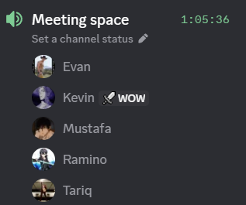
Discussed which documents we have to keep up with (09-04): We’ve discussed which documents we have to actively work on in order to not get overwhelmed in later stages of the project.

Stand-up/meeting (14-04):
Discussed testing about unit testing and system tests what needs to be done before sprint 2 and discussed what userstories needs to be done and what needs testing and added some new userstories for sprint 2.

Screenshot of stand-up/meeting:
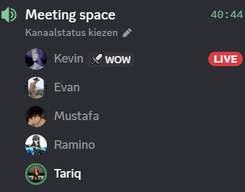
proof of product backlog(14-04):
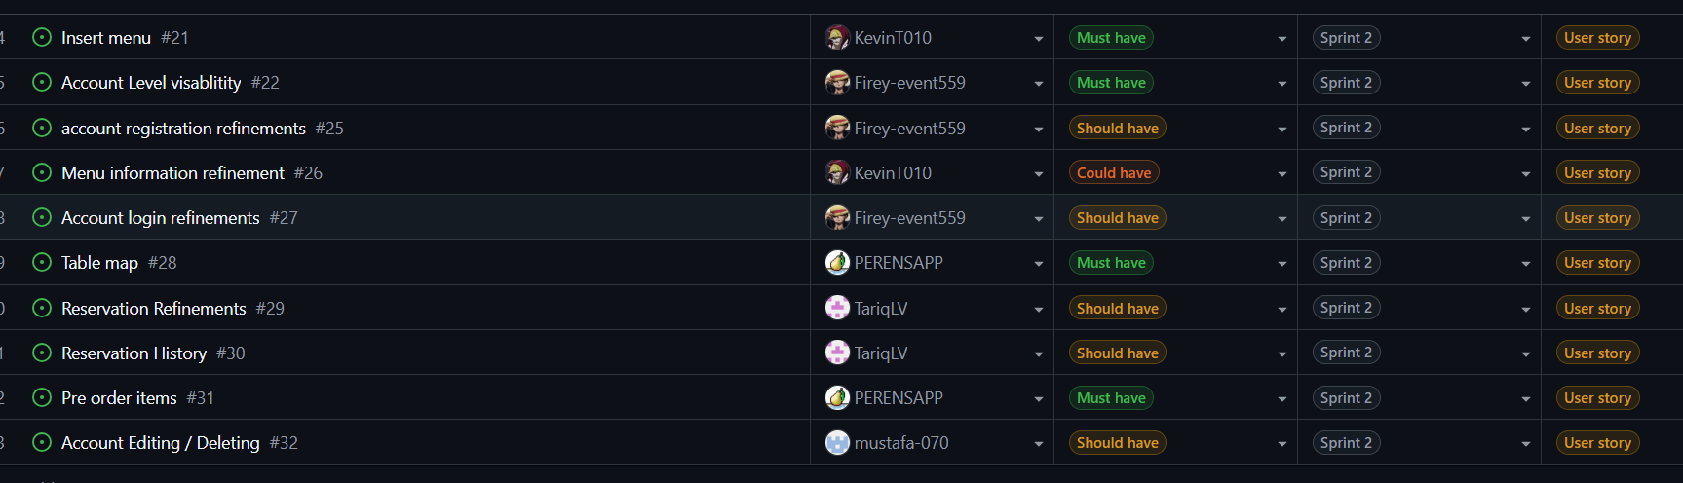

Stand-up/meeting (21-04):
discussed what needed to be done before the sprint review and everybody told what they were going to do.

screenshot of stand-up/meeting(21-04):
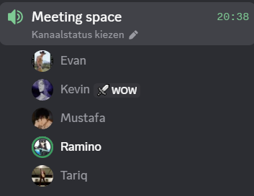
proof of product backlog(21-04):
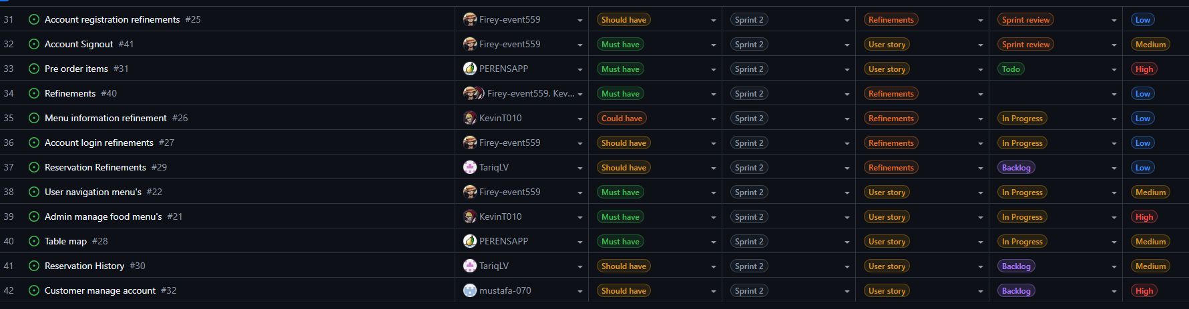

Sprint 3
No meeting because of a 1 week holiday.

Screenshot planning meeting(05-05):
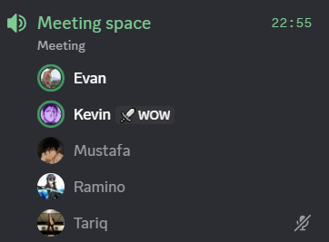

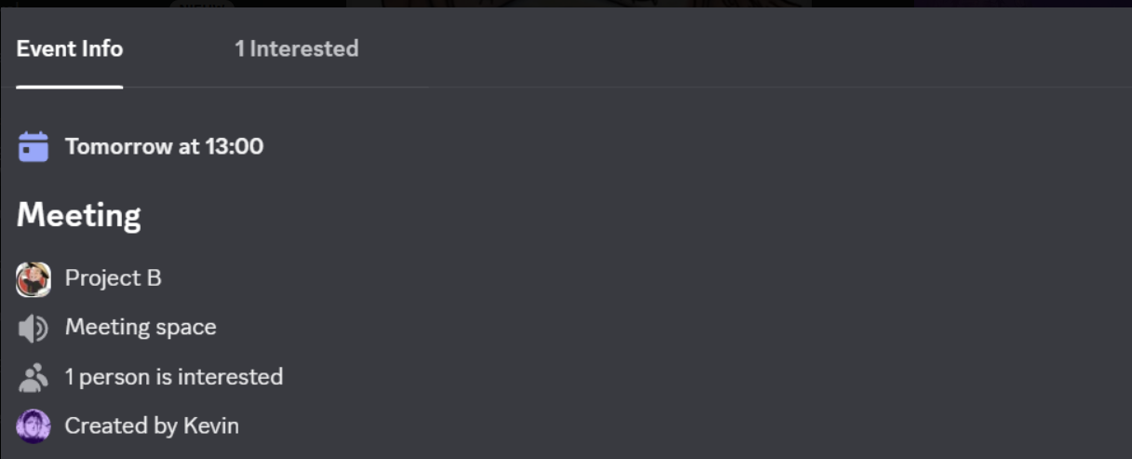

Stand-up/meeting (05-05):
Discussed the user stories and and everyone told what they were going to do in the sprint 3. Everyone created their userstory and acceptance criteria for all userstories.

proof of product backlog(05-05):
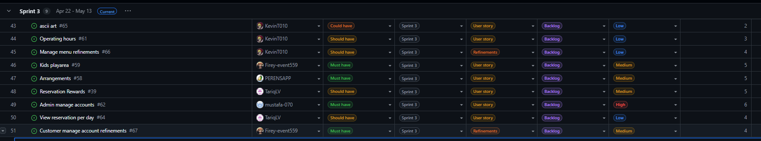

Sprint 4

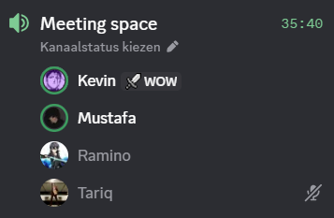
first meeting of our sprint 4 on the first thursday of the sprint

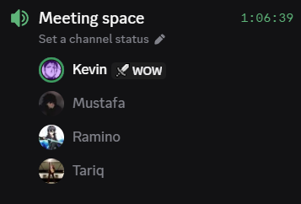
another one of our meetings this sprint on the last tuesday of the sprint

Sprint 5
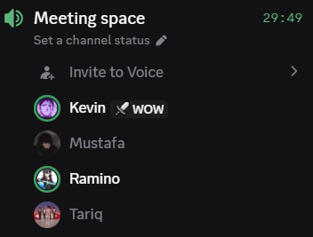
our first meeting of the sprint 4-6-2026
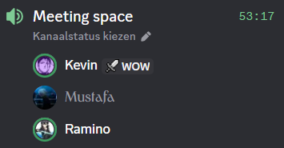
our last meeting of the sprint on 9-6-2026

